1. Primary Custom Board Infrastructure
To ensure the custom MSP430FR6043 PCB operates reliably and communicates accurately with both the physical gas environment and the host PC, four primary subsystems must be established with strict attention to signal integrity.
- Ultrasonic Transducer Integration: The upstream and downstream Jiakang 200kHz air transducers are directly soldered to the analog front-end Ultrasonic Sensing Solution (USS) channels. These channels correspond to the X1 and X2 excitation/receive pins on the evaluation module. Careful trace routing here is critical; the analog paths must be kept as short as possible and isolated from high-speed digital switching noise to maintain the integrity of the captured microvolt-level acoustic envelopes.
- High-Precision Clocking Architecture: The internal USS module and its high-speed sigma-delta ADC require a highly stable time base to perform accurate cross-correlation. A high-precision external crystal oscillator is connected to the MCU's designated High-Frequency (HFXT) oscillator pins. To ensure stable oscillation and prevent startup failures, the crystal is flanked by two 33 pF load capacitors tied to the ground plane. This hardware modification pairs directly with the firmware adjustment that increases the crystal settling time to 5000 μs.
- Standalone Data Telemetry (UART): For continuous data logging and visualization, a dedicated UART pipeline is established. The board's UART TX, RX, and GND pins are routed out to an external USB-to-Serial bridge (FTDI adapter). This standalone pipeline continuously streams calculated metrics—Absolute Time of Flight (AbsToF for UPS and DNS), Delta ToF (DToF), and Volume Flow Rate (VFR)—directly to your custom Python GUI without relying on the TI programming tools.
- Onboard Programming Interface: The MCU's ezFET/JTAG pins are broken out to test points or headers on the custom board. This allows seamless firmware flashing and live debugging using the Spy-Bi-Wire (SBW) protocol via the TI Uniflash tool or Code Composer Studio.

2. EVM Hardware Configuration & Isolation
To avoid purchasing a dedicated standalone JTAG programmer (like an MSP-FET), the system intelligently utilizes the built-in ezFET debugger section of the EVM430-FR6043 evaluation board.
Isolating the EVM Target: Before establishing the bridge, it is mandatory to physically isolate the EVM's onboard MSP430FR6043 microcontroller from its own ezFET circuitry. This is achieved by removing jumpers J1, J2, and J3. Removing these jumpers severs the power, data, and programming connections to the EVM's internal target, preventing electrical collisions and allowing the ezFET debugger to drive your custom board exclusively.

3. Hardware Connection Mapping
With the EVM's target MCU isolated, jumper wires are used to bridge the EVM's ezFET headers directly to the corresponding test points (TP) and pins on the custom PCB.
Below is the definitive wiring configuration required to establish power, communication, and control.
Connection Type | EVM430-FR6043 Header | Custom Board Target | Purpose
Comms (UART RX) | J3 (RXD) | J1 (RX) | Routes custom board serial output to the PC via the EVM's USB bridge.
Comms (UART TX) | J3 (TXD) | J1 (TX) | Allows the PC to send serial commands back to the custom board.
I2C Clock | J1 (SCL) | J1 (SCL) | Synchronizes data transfer for I2C peripherals.
I2C Data | J1 (SDA) | J1 (SDA) | Bidirectional data line for I2C peripheral communication.
Control (Reset) | J3 (RST) | TP1 (Reset) | Spy-Bi-Wire data line (SBWTDIO) and system reset control.
Control (Test) | J3 (TEST) | TP20 (Test) | Spy-Bi-Wire clock line (SBWTCK) for firmware flashing and debugging.
Interrupt | J1 (IRQ) | J1 (IRQ) | Hardware interrupt line for peripheral-to-MCU signaling.
Power (VCC) | VCC Header/Pin | TP21 (VCC) | Supplies 3.3V power from the EVM to the custom board.
Common Ground | GND Header/Pin | Pin 6 (GND) | Establishes a common ground reference for logic levels and power.

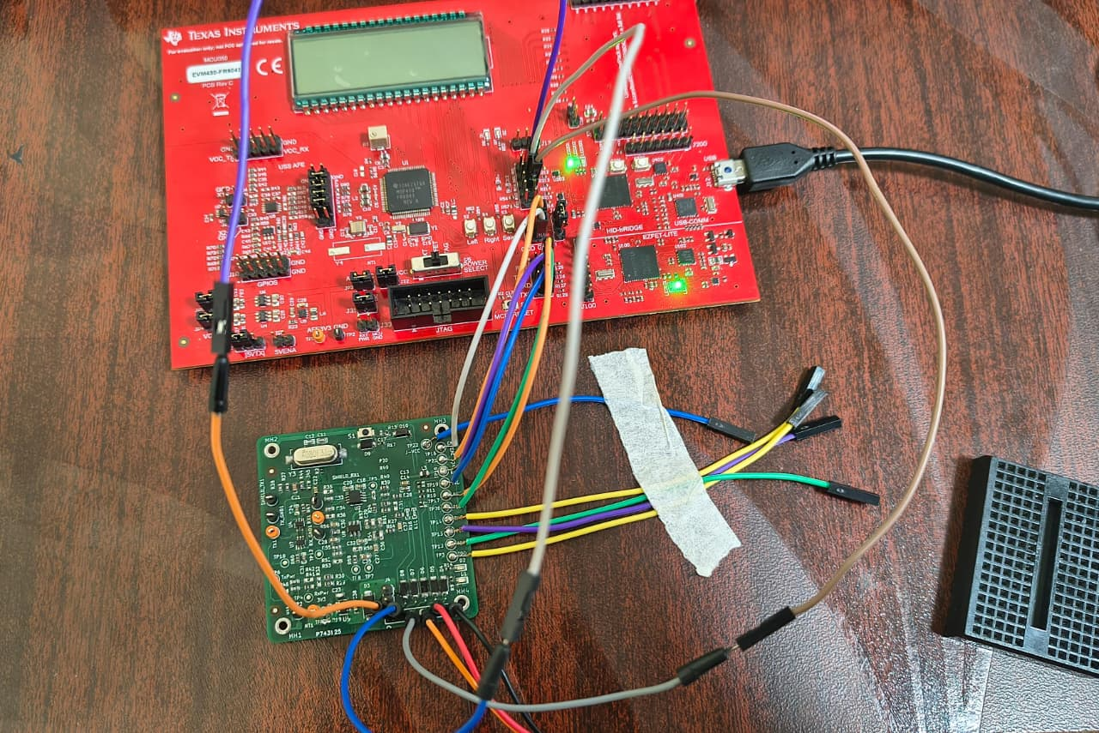
Fig: Board connection between EVM and Custom board

